DATABASE SYSTEM PRINCIPLES

DIGITAL ASSIGNMENT-3

NAME:HRITHIK HEM SUNDAR.B

REGNO:19MID0021

SOFTWARE : MYSQL

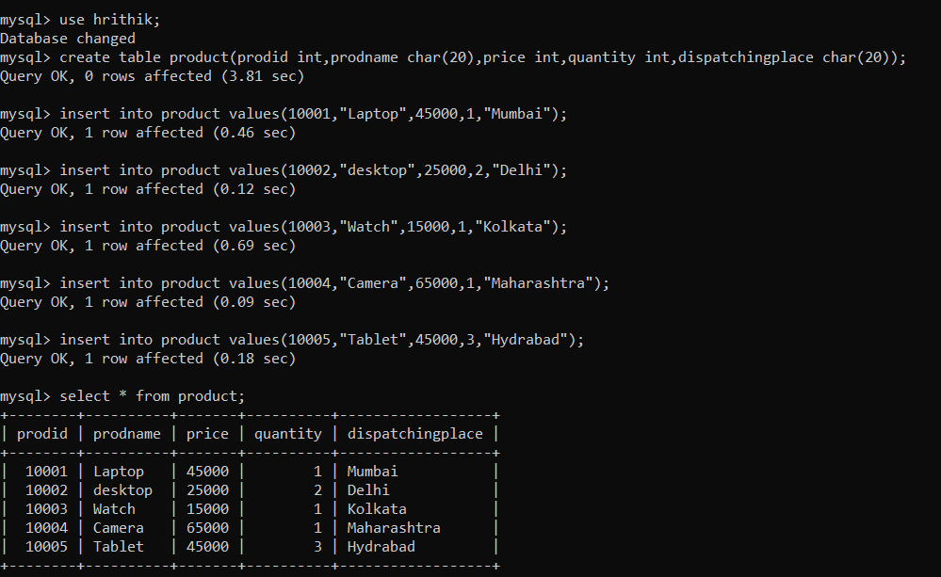1.CREATING THE TABLE AND INSERTING THE VALUES.

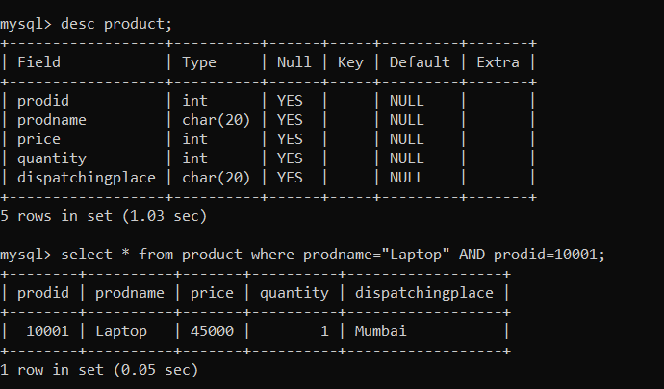2.DESCRIBING THE TABLE AND SELECT COMMANDS USING WHERE CLAUSE.

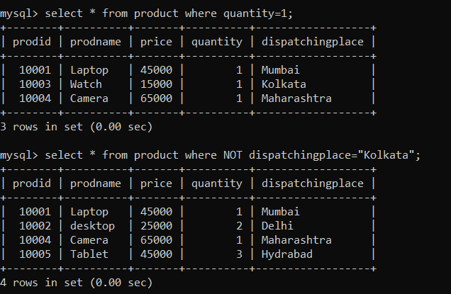

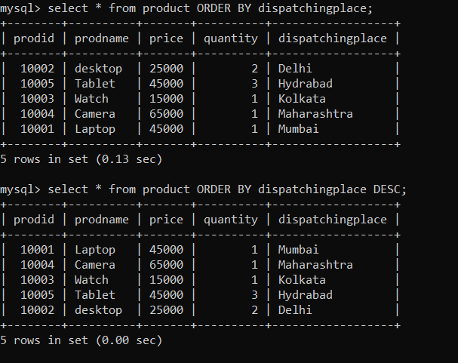3.SELECT COMMAND USING ORDER BY

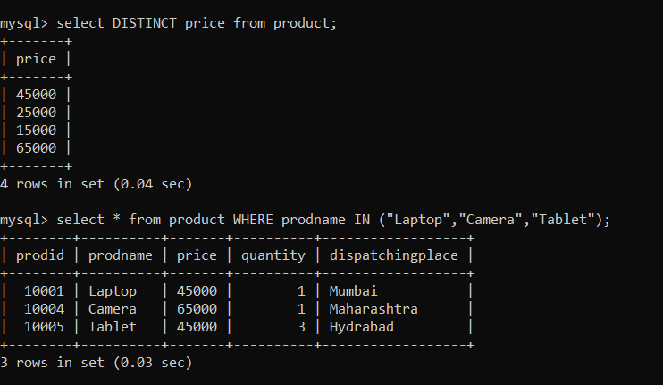4.SELECT COMMAND USING DISTINCT

5.SQL COMMANDS USING OPEARTORS

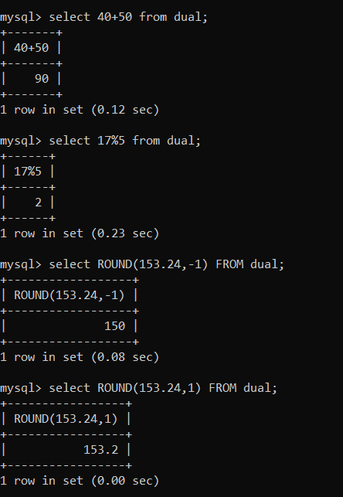

6.CREATING A NEW TABLE FOR FUNCTIONS

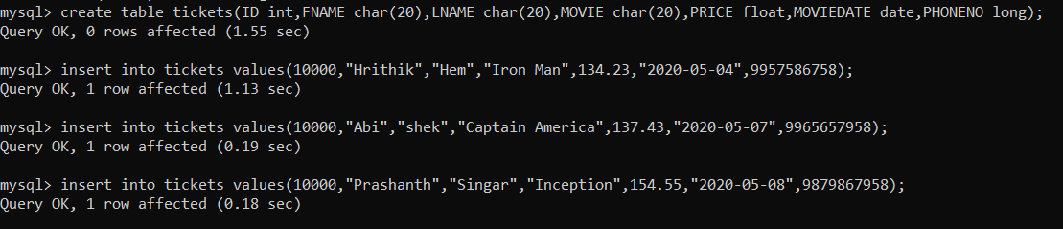

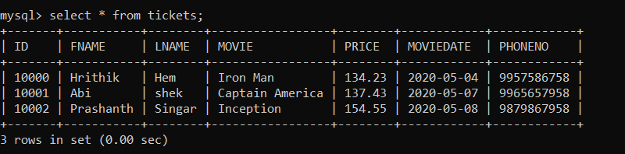

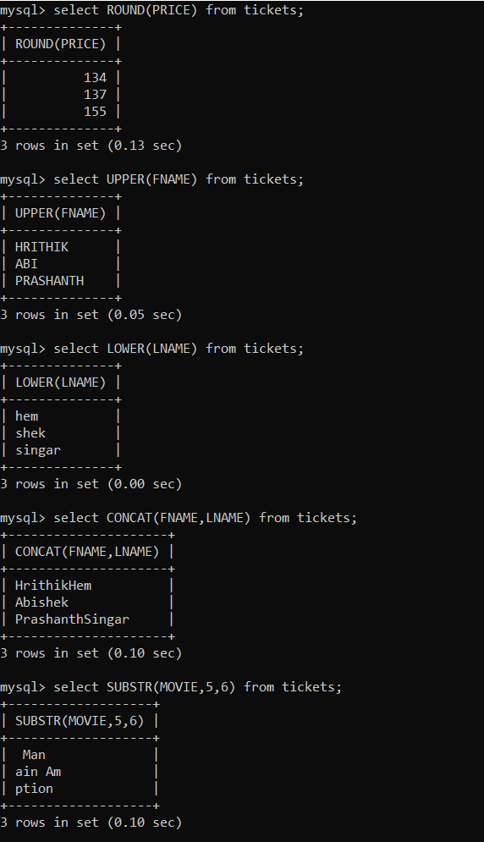7.OPERATIONS

